Practical 1
Part A
1) | Vending machine (VendingMachine.java, main in this file)  (a) Define an enum Coin with constants ONE, TWO, FIVE, TEN.  (b) In main, set a snack price of 15 and a running total of 0; create a Scanner.  (c) Loop: read a coin name, use a switch expression to convert the Coin to its value  (ONE→1, TWO→2, FIVE→5, TEN→10), add it to the total, and print the total so  far.  (d) Stop the loop once the total reaches 15 or more.  (e) Print the change to return (total − 15).
 | VendingMachine.java
Code | import java.util.Scanner;  enum Coin { ONE, TWO, FIVE, TEN }  public class VendingMachine {  public static void main(String[] args) {  Scanner sc = new Scanner(System.in);  int price = 15;  int total = 0;  while (total < price) {  System.out.print("Enter coin: ");  Coin coin = Coin.valueOf(sc.next().toUpperCase());  int value = switch (coin) {  case ONE -> 1;  case TWO -> 2;  case FIVE -> 5;  case TEN -> 10;  };  total += value;  System.out.println("Total: " + total);  }  System.out.println("Paid. Change: " + (total - price));  }  }
Output | 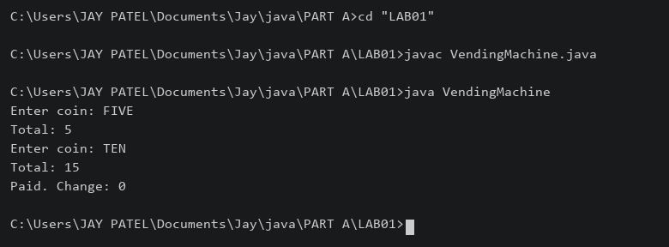

2) | Toll booth (TollBooth.java, main in this file)  (a) Define a record Vehicle(String number, String type).  (b) In main, keep a running toll total and three counters (bike, car, truck).  (c) Loop until the user types “done” for the number: build a Vehicle, use a switch  expression on its type for the toll (bike→20, car→50, truck→150), add to the total,  and increment that type’s counter.  (d) After the loop, print the total toll and the type with the highest count.
 | TollBooth.java
Code | import java.util.Scanner;  record Vehicle(String number, String type) {}  public class TollBooth {  public static void main(String[] args) {  Scanner sc = new Scanner(System.in);  int total = 0, bikes = 0, cars = 0, trucks = 0;  while (true) {  System.out.print("Number or done: ");  String number = sc.next();  if (number.equalsIgnoreCase("done")) { break; }  System.out.print("Type: ");  Vehicle v = new Vehicle(number, sc.next().toLowerCase());  int toll = switch (v.type()) {  case "bike" -> 20;  case "car" -> 50;  case "truck" -> 150;  default -> 0;  };  switch (v.type()) {  case "bike" -> bikes++;  case "car" -> cars++;  case "truck" -> trucks++;  default -> System.out.println("Invalid type");  }  total += toll;  }  System.out.println("Total toll: " + total);  if (bikes + cars + trucks == 0) {  System.out.println("Most frequent: none");  } else {  int max = Math.max(bikes, Math.max(cars, trucks));  if (bikes == max) { System.out.println("Most frequent: bike"); }  if (cars == max) { System.out.println("Most frequent: car"); }  if (trucks == max) { System.out.println("Most frequent: truck"); }  }  }  }
Output | 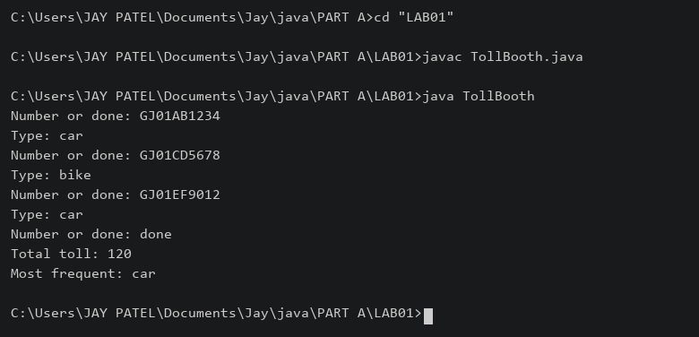

3) | (For Advanced Learners – home) Rock-Paper-Scissors-Lizard-Spock (RPSLS.java)  (a) Define an enum Move with ROCK, PAPER, SCISSORS, LIZARD, SPOCK.  (b) Write winner(Move a, Move b) returning 1 if a beats b, -1 if b beats a, 0 for a tie —  use a switch expression listing what each move beats (Scissors cut Paper, Paper  covers Rock, Rock crushes Lizard, Lizard poisons Spock, Spock smashes Scissors,  and the five mirror cases).  (c) In main, play 5 rounds: pick a random computer Move, read the player’s Move, call  winner(), print the round result and keep score.  (d) After 5 rounds, print the overall winner.
 | RPSLS.java
Code | import java.util.Random;  import java.util.Scanner;  enum Move { ROCK, PAPER, SCISSORS, LIZARD, SPOCK }  public class RPSLS {  static int winner(Move a, Move b) {  if (a == b) { return 0; }  boolean win = switch (a) {  case ROCK -> b == Move.SCISSORS || b == Move.LIZARD;  case PAPER -> b == Move.ROCK || b == Move.SPOCK;  case SCISSORS -> b == Move.PAPER || b == Move.LIZARD;  case LIZARD -> b == Move.PAPER || b == Move.SPOCK;  case SPOCK -> b == Move.ROCK || b == Move.SCISSORS;  };  if (win) { return 1; }  return -1;  }  public static void main(String[] args) {  Scanner sc = new Scanner(System.in);  Random random = new Random();  int player = 0, computer = 0;  for (int i = 1; i <= 5; i++) {  System.out.print("Your move: ");  Move a = Move.valueOf(sc.next().toUpperCase());  Move b = Move.values()[random.nextInt(5)];  System.out.println("You: " + a + " Computer: " + b);  int result = winner(a, b);  if (result == 1) { player++; System.out.println("You win round"); }  else if (result == -1) { computer++; System.out.println("Computer wins round"); }  else { System.out.println("Tie"); }  }  if (player > computer) { System.out.print("You win "); }  else if (computer > player) { System.out.print("Computer wins "); }  else { System.out.print("Draw "); }  System.out.println(player + "-" + computer);  }  }
Output | 

